## LOGIN/SIGNUP

This is a welcome screen for my application. Because this application will involve different users such as students, teachers and employers, therefore, three type of accounts will be created:

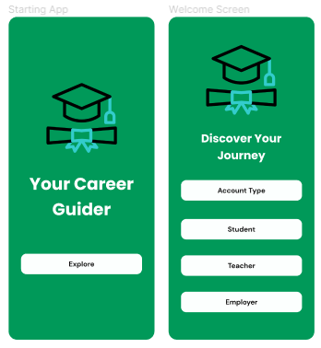

After selecting account type, the sign-up screen will appear. If user is new to this platform then he needs to create an account, otherwise he will use the login screen. In the signup process, user will be recognized by his unique ID and email in order to provide security to every user.

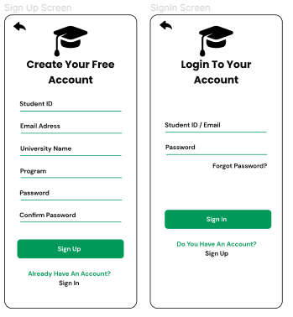

## HOME SCREEN

Below is a home screen, which provide different options to users such as user profile, community support, gamification and so on. Apart from that, if user select the career path then it will show him the find program and job options. If he selects program then he can enter different options to explore his interest by adding and removing multiple filter options.

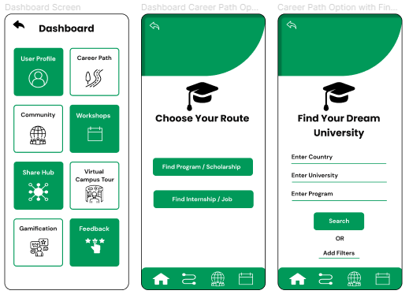

After adding different filters, he selected the University of Oulu and then mobile application will show him the relevant information.

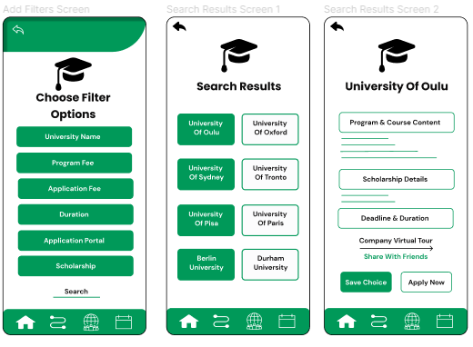

Similarly, user can also find job and internships positions:

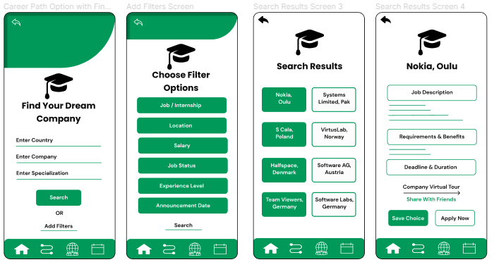

## PROFILE SCREEN

This is a profile screen which shows the user information such as name, id, email, password and his saved selection. Moreover, application will also provide modification where he can also edit his profile setting in order to increase his interest.

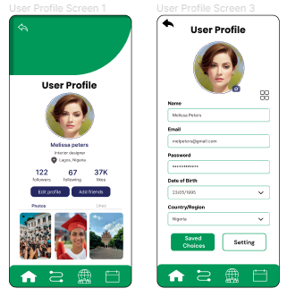

## SPECIFIC FUNCTIONALITIES

**Community Support**

This feature will help the user to connect with previous and current students and also get the support from teachers and employers through communication with the help of different platforms.

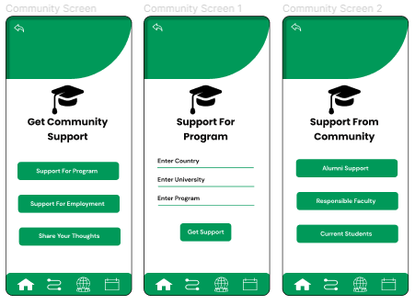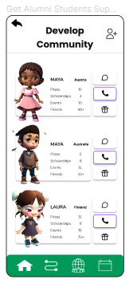

Moreover, they can also share different posts through this platform and get opinions of other individuals:

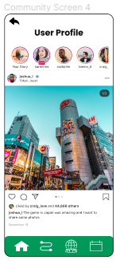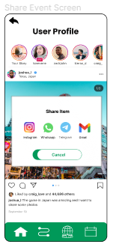

**Share Hub**

Apart from that, user can also add new information which will be useful for other people:

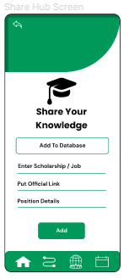

**Virtual Campus Tour**

Another interesting functionality is that students can get virtual tours of different universities and companies in which they have interest and also share them with their friends:

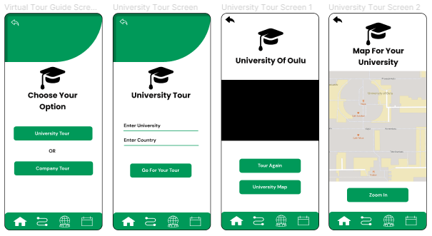

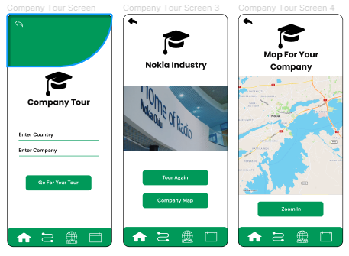

**Gamification**

This feature will help them to check their progress and their winning awards:

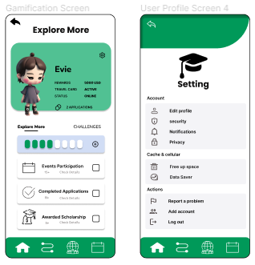

**Events/Workshops Information**

This will provide them information relating to different events regarding jobs and scholarships:

